Considerations for Covid Vaccine Rollout in a Health Authority

November 27, 2020

INTRODUCTION

We were asked by a Health Authority to have a look at modelling the rollout of Covid vaccines in 2021, and in particular the schedules that may pertain to the mass vaccination that is anticipated to begin in March, for the specific population.

The initial 40,000 doses of vaccines coming in December 2020/January 2021 are not in question, as they will have urgent priorities assigned to them by management.

A discussion of the framework for approaching this set of questions is included in the Appendix at the end of this document.

This is an initial and preliminary examination of one part of this problem, with assumptions as follows.

CONTEXT AND ASSUMPTIONS

The strategic approach to the staged vaccination of the entire population could be based on one of the following:

1. Protect the vulnerable – the elderly, those with known co-morbidities (obesity, renal disease, sever heart disease) etc. to reduce severe cases, hospitalizations and deaths.
2. Reduce the risks of transmission by targeting persons who work or occupy spaces over significant periods of time in poorly ventilated, crowded spaces in which there is high mingling.
3. Follow the influenza vaccination approach – open clinics, first come first serve – essentially a randomizing approach.

The initial studies described below considers the approach to (3) – the random approach, so that from the public’s point of view, no one need be placed at the back of the line.

We will be considering approaches to (1) and (2) subsequent to this report.

The question of the benefits of particular strategies for scheduling vaccination clinics was posed to the group – should they be staged equally, or heavily invested in rapid deployment?

The factor that is raised by this question is the relative urgency at the time of rollout – March 2021. If the epidemic is raging, there would be great urgency, but if the epidemic is controlled and cases have reduced on a daily basis to the rates of summer 2020 or better, there is less urgency.

We try to consider both situations in our modelling, described below.

Finally, the cost-benefit question was raised – would the saving in case management and everything downstream of it be sufficient to justify the layout of investment for deploying the infrastructure in IT, logistics, staffing to vaccinate the entire population rapidly?

This question is not addressed in this report, as it requires some detailed knowledge of costs on both sides, which we do not have.

THE MODELLING APPROACH

For this study, we have used the CovidSIMVL agent-based model, not as a predictor of BC numbers, but as a tool for exploring the different outcomes that arise from various vaccination schedules in conditions of an exponentially growing epidemic (by March 2021) and of a relatively stable but persistent epidemic. We characterize the epidemic intensity by the R0 values that result from input parameters to the models, as they execute.

For those not familiar with the CovidSIMVL agent-based model, you are referred to the documents found in [www.github.com/ecsendmail/MultiverseContagion](http://www.github.com/ecsendmail/MultiverseContagion).

Some relevant aspects to note, as used in this project, are:

1. CovidSIMVL uses agents in the physical analog sense – they have positions within a fixed arena, and they move according to rules of MonteCarlo simulation.
2. The viral temporal dynamics of Xi, He (Nature Medicine, April 2020) is used to implement interaction between susceptibles, infected, incubating, contagious and inert.
3. The parameters that most affect the behaviour of an epidemic model are”
   1. the number of interacting agents
   2. their base size in pixels (which can be affected by viral states)
   3. the degree of mingling of each person, and of the universe they occupy
4. The fundamental rule is that if the stochastic movements of the agents in a cycle result in one or more transmitting agents overlapping susceptible agents, then viral transmission takes place, and the state of the agent changes, progressing along the temporal dynamic of Covid.
5. We use 100 agents, and time in days and hours, with one hour being one generation. The number of agents could be considered a percentage, but is best seen as an exemplary cohort.

STUDY 1 – IN THE CONTEXT OF A RAPID GROWTH EPIDEMIC

In a population of 100, and one initial transmitting agent (“infectious” for the non-U speakers), with a Hazard Radius (size of agent) of 3, and a mingleFactor of 5, we have, at the times and generations as shown, the number of remaining susceptibles, from which, in the no-vaccination context, the number of positive cases is its difference from 100. This is shown below:



The column “noVax” refer to

the susceptibles remaining, and

R0 is calculated by the precise

count of the number of transmissions

by agents who are or have been

contagious.

No one is left in 21 days.

Using this set of parameters, we run the simulation with the following vaccination schedules:



For all the schedules, the percentages are of the remaining susceptibles. Thus, they will be a smaller number as the epidemic progresses in time, for Schedules VaxA to VaxD. The schedule VaxE is an approximation of maintaining a constant number of agents protected.

So running the model VaxA, gives the following result, compared to noVax:



The column VaxA – G gives the count of susceptibles remaining at the Generation, and so the number of sick patients (cases) would be 100 less the susceptibles less the numbers protected by vaccination. We use the number of susceptibles x 5/6 to account for no-Vaxers (generally held to be 1/6 of the population). Then we take 95% of that for the reported efficacy of the vaccines (Pfizer and Moderna). At this point, we have not taken into account the no-show percentage for the second injection. The schedules above are the times for the second injection, and protection is assumed to be instantaneous, for the purposes of the model.

The important thing is of course to compare the noVax Cases column with the VA Sick column at the corresponding times, and to observe the difference in case counts, which correspond to overall reductions in cases. The savings from reduction of cases go all the way from contact tracing, quarantine self-reporting and monitoring, to the 20% severe cases that require treatment, the 10-15% hospitalization, the 5% ICU and the 2% deaths. Of course, these numbers vary for different jurisdictions, and we do not know what to apply in the case of Island Health, come March 2021.

The benefits for Schedule A start at Gen 200, and by Gen 400 (Day 16), reach 60% of what would have been the cases.

The table for all Schedules look like this, with the corresponding graphs:



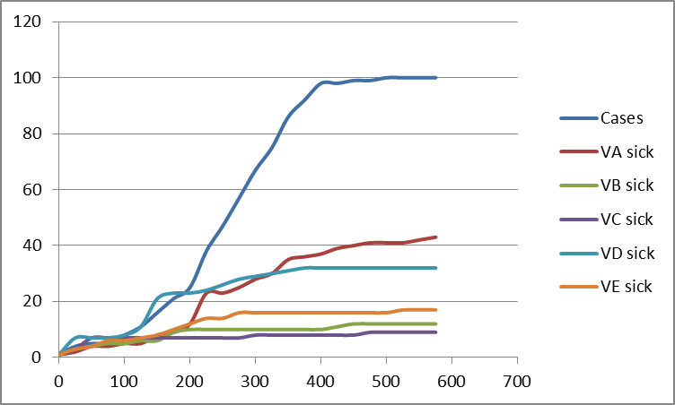

We would expect that Vax schedule C, at 80% each step, would protect more agents than Vax A or Vax B, and indeed, Vax C is the bottom line and is superior in number of ill patients than the others.

The CovidSIMVL is a stochastic model, and therefore subject to the some random variation in initial and subsequent geographic distributions of the agents, and therefore in contacts made between transmitters and susceptibles. Similarly the no-Vax case data is a single run with the parameters.

The difference between Schedule C and Schedule D is that D starts at gen 150, two steps later. The purpose is to see the difference that delays might make. We graph these two separately to illustrate the point.

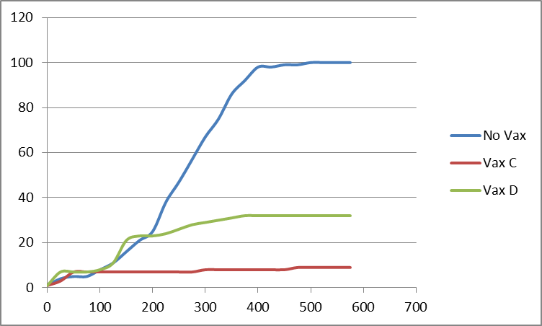We see that instead of a 90% improvement for Schedule C from the no-Vax cases, we are only getting about 66%, a loss of some 25% of benefit. The numerica l differences from the no-Vax case is shown.

It is clear that Schedule C, with 80-80-80-80 gives most protection, while Schedule B at 50-50-50-50 is second. The rule appears to be:

START AS EARLY AS YOU CAN WITH AS MUCH AS YOU CAN

We turn now to consideration of an epidemic which is slower than this one, which has an R0 of 5.15. The next has an R0 < 2.0.

STUDY 2 – A SLOWER EPIDEMIC

What we have done in parameter setting is to make the Hazard Ratio small 1.1 (instead of 3), but to compensate for this we have increased the mingleFactor to 50. The following diagrams show the differences in area covered by the stochastic move generation algorithm with the different mingleFactors when the size is small (because the proposed move is a function of size).

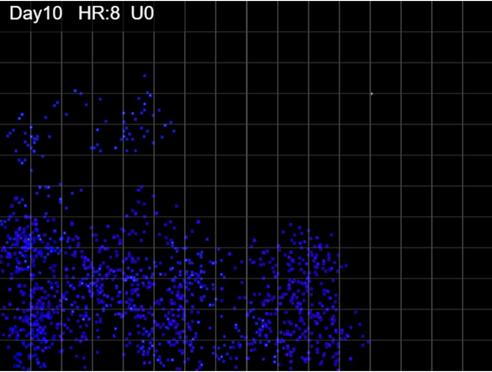

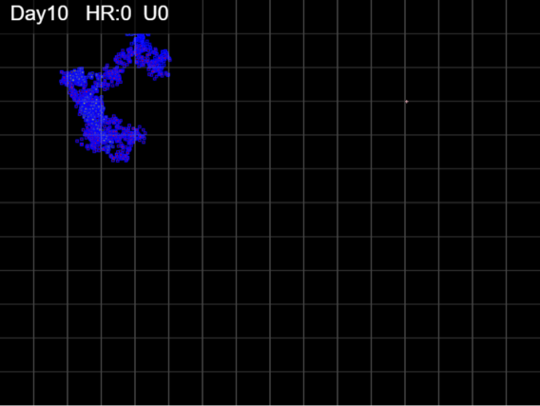

Hazard Radius 2, mingle Factor 10 Hazard Radius 2, mingle Factor 50

The high mingleFactor permits the simulation to have agents reach susceptibles in distant locations more than using a lower mingleFactor, which tends to maintain the locality of agents. Thus, with small sizes, one can nevertheless continue transmissions with large time intervals, leading to lower intensity epidemics.

We will not go through the detailed steps as in the last section, but present the summary findings. We used the following set of schedules:



The results may be surprising, but it is in a

situation where the epidemic is slow in new

cases, so that the prevention schedules that

take place in the first 12 days are all highly

effective in removing susceptibles from the pool and making them immune. The numbers of ill agents by the time the epidemic reaches termination is in all these schedules low, which means that benefits were easier to come by.

The models under this set of parameters all self-extinguished. This means that although there were susceptibles left, the transmitters were not able to find them, even with the high mingleFactor, within the time frame of the viral temporal model. Our interpretation for Schedule C is that with200 generations of no removal for immunity, more transmitters were created that could work on the susceptible pool.

FIN

APPENDIX. Memo to Ken, Nov 24, 2020 from ecsendmail@gmail.com

Some steps for mass vaccination starting March 1. I suggest:

.

1. Propose scenarios of the pandemic in IH's 965K (is this about right)...should we call it 1 million for all the refugees coming...

2. Look at three strategic approaches in their pure sense:

     a. Random approach - like flu clinics -

     b. Protect the vulnerable

     c. Reduce spread

3. Staging in six scenarios;

     a. all on March 1 - repeats March 23 -

     b. staged equally over 6 months

     c. pulsed asymmetrically - say 20% + 30% + 30%  + 10% + 10% or

                                                       30% + 30% + 30% + 10%

4. Population reached

    a. 95% effective + noVaxers + noReturns

    b. asymmetric may be targeted if protective or reduction strategies used

5. Outcome measures

    a. Case reduction (all positive cases)

    b. Hospitalization reductions

    c. Deaths reductions

6. Stratified outcome measures

    a. among vulnerable populations - health status index will help

    b. reduction of spread

IMMEDIATE

1. figure out 3 lines of projection for scenarios - from existing curves

2. random approach can be modelled by Single Universe - try this

3. Vulnerable - need population figures for health care workers, LTC, comorbid and

    age grouping

4. Reduction of spread - try to figure out who and where the major transmitters are, and

    vaccinate the persons and their families eg

    - religions leaders and consistent congregations and families

    - prisons and other incarceration sites

    - police, firefighters and families

    - pharmacy staff and families

    - food production (meat and poultry packers), large warehouse store staff,

    - shopping mall stores staff and families; recreation facilities; exercise facilities

    - restaurant and bar staff

    - projected weddings, conference attendees and staff and families

    - hospitality staff and families